1 hour | Task 1: Forms and Semantics
There’s a wide range of functionality available within HTML. As we’ve learnt this week, we can use Tables and Forms without relying on CSS or JavaScript to function appropriately within our browser.

Please watch the following video (HTML Forms) for a re-cap on using HTML to create a form on a web page. Once you’re happy with the content, move on to the second video (HTML Semantics) to learn more about some of the newer elements available in HTML5 (hint: we briefly looked at <section> in this week’s session!) These are important to know whilst we are readying ourselves up for introducing CSS in next week’s session.

HTML Forms – Tutorial
HTML Semantics - Tutorial

2 hours | Task 2: Creating Tables
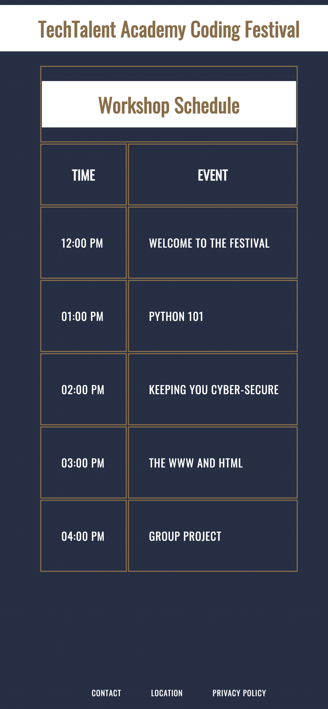
Brief

TechTalent Academy is having a festival!

Your job is to create the table for the event webpage using all of the new element tags we have learnt in this week’s session.

Your page should look like the one on the right-hand side:

Attached to this week’s assignment is an index.html that has been pre-populated with some information, as well as a style.css that has been linked to the HTML document.

Once complete, please copy in your code into the box on the next page – and provide a screenshot of your code.

Don’t forget to sync your work to your GitHub! You should create a new folder called Week 3 HLT and enter your work into a folder called ‘TTA Coding Festival’.

Copy your code into the box below:

Provide a screenshot of your web page here:

Brief update

TechTalent Academy need to make a few changes to their schedule:

- The event is now running over 2 days (Saturday and Sunday)
- Python 101 session is now taking place at every hour from 11am-3pm.
- On Sunday the 3pm session (The WWW and HTML) is not taking place. Instead it is being replaced with a CV workshop.
- On Sunday at 5pm, the festival will have a closing speech from the CEO.

The client (TechTalent Academy) would like to have one single table for the entire event, rather than one for each day.

Once you have made your changes, please copy your code into the box below and provide a screenshot.

Copy your code into this box:

Provide a screenshot of your completed event page:

Marking criteria (Task 2)

 | Pass | Merit | Distinction
Structure | - Use of <html> tag incorrectly placed  - <!DOCTYPE html> used correctly | - Use of <head> and <body> tag accurately  - Attempts to use the <title> tag | - Multiple levels of nesting including grandchildren, great-grandchildren.  - <title> tag used correctly across the website
Tables | - Attempts to create a table (multiple errors)  - Use of <table> tags correct and accurate | - Table has clear headings throughout | - Use of <span> attributes applied correctly and appropriately throughout
Presentation | - Some whitespace used to good effect  - Indentation attempted but inaccurate  - Correct HTML naming convention | - Whitespace used appropriately, at times  - Indentation largely accurate | - Website meets W3C standards consistently  - Clear commentary provided throughout  - Code is explicitly clean and easy to read

2 hours | Task 3: HTML Forms – The Good Vibes Form
Here at TechTalent Academy we are all about positivity and inspiration.

We love sharing our successes! ☺

Your task is to create your own Good Vibes Form (like the one pictured below). This task is to demonstrate all the tags we covered in this week’s session (plus a few extra – if you’d like a challenge!)
I’ve provided you with a started .html file as well as a style.css for you.

Remember: You should include commentary throughout your work to explain the rationale for a particular section.

Don’t forget to sync your work to your GitHub! You should create a new folder called Week 3 HLT and enter your work into a folder called ‘Good Vibes Form’.

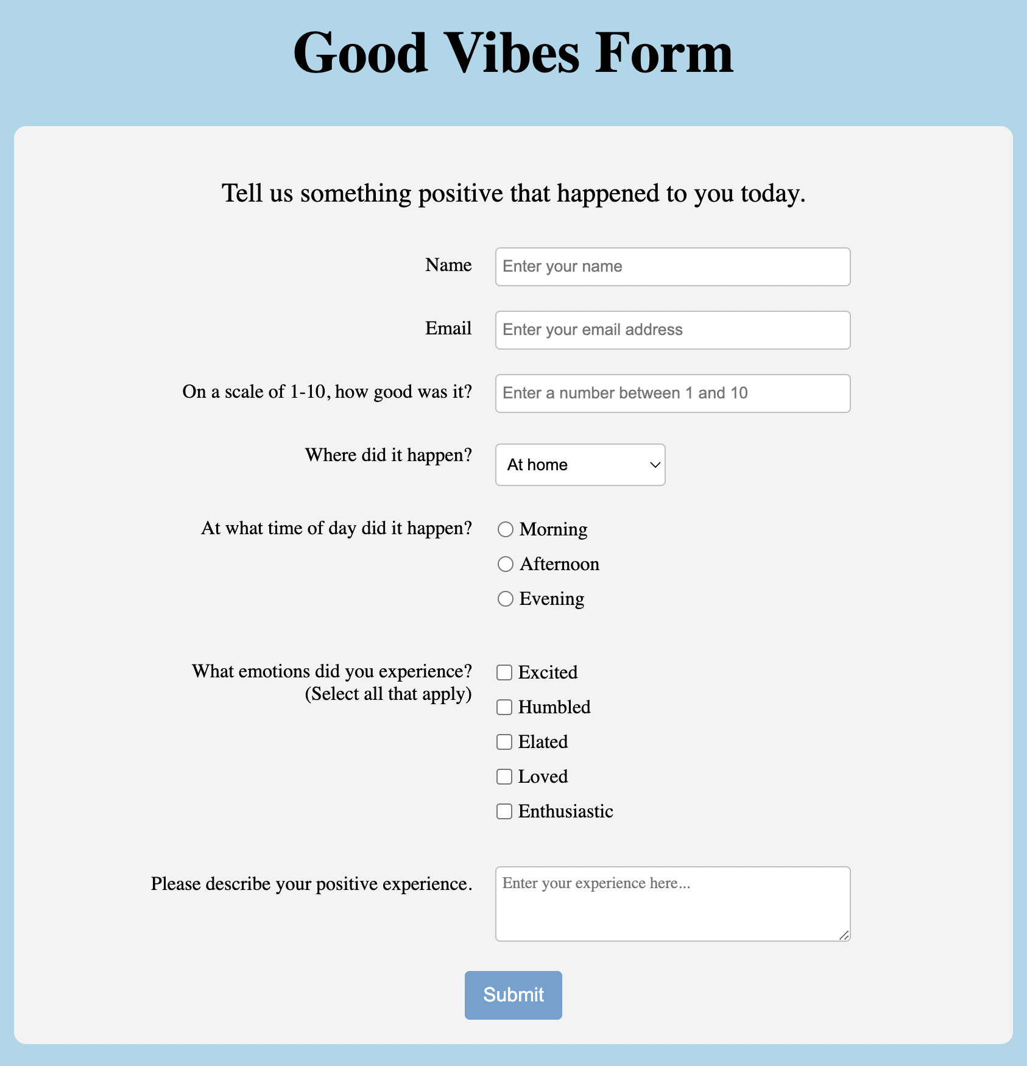 |  | This is the minimum expectation of what the form should include.  You are welcome to add a range of additional <input> tags and options, as you see fit.
Once complete, please copy your code from index.html below:

Provide a screenshot of your completed code:

Marking criteria (Task 3)

 | Pass | Merit | Distinction
Structure | - Use of <html> tag incorrectly placed  - <!DOCTYPE html> used correctly | - Use of <head> and <body> tag accurately  - Attempts to use the <title> tag | - Multiple levels of nesting including grandchildren, great-grandchildren.  - <title> tag used correctly across the website
Elements | - Use of 2 <input> tags | - A range of <input> tags used (range, checkbox, radio etc.) | - A wide range of <input> tags used throughout
Presentation | - Some whitespace used to good effect  - Indentation attempted but inaccurate  - Correct HTML naming convention | - Whitespace used appropriately, at times  - Indentation largely accurate | - Website meets W3C standards consistently  - Clear commentary provided throughout  - Code is explicitly clean and easy to read
Accuracy | - Attempts to replicate form from screenshot | - Form is largely an accurate representation with sustained attempts at developing further content | - Form is accurate as per screenshot and extensive additional material written and functioning

